Jenna Fowler

Professor Nguyen

Computational Methods in the Civic Sphere

Bot 1 Write-up

Following the Money in Palo Alto’s Council Race

PALO ALTO, CA -- “Is someone trying to buy Palo Alto?,” reads the first line of a [letter](http://www.paloaltoonline.com/news/reports/1476859783.pdf) written in October by eight former Palo Alto mayors Betsy Bechtel, Larry Klein, Bern Beecham, Sid Espinosa, Dena Mossar, Leland Levy, Lanie Wheeler and Gail Wooley.

The letter called out five Palo Alto families who contributed the most toward the 2016 city council race. When the letter was sent, the families had given more than $150,000 to two candidates and one political action committee.

By the end of the race, the 11 candidates vying for four open seats on the city council received more than half a million dollars in political contributions, breaking a record for the amount of money raised in a Palo Alto council race. Nine of the candidates and a political action committee received $543,287 in contributions, more than one-and-a-half times the amount that was raised in the 2014 race.

“Not only are these contributions shocking and deeply troubling, but checks for $5,000 or more are unexpected in our City Council elections,” the mayors said in the letter.

The “five families” as they became known, contributed close to 37 percent of the total money received by candidates during the election. A sum of their total contributions to the race is included below.   
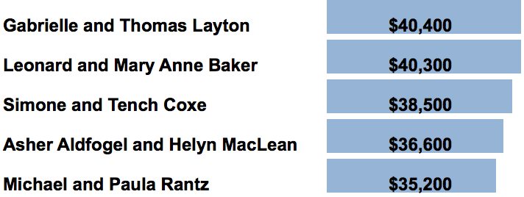

“The people who are more in line with the residential community, the people who have been here a long time, people who care about the future of Palo Alto long term, they don’t really even have any money. They get very small contributions, they’re not very organized, and we just felt like we wanted to support them,” Mary Anne Baker said in interview.

The amount of money raised during the election underscored the contentious nature of the race. Among the top contributors -- each of whom gave more than $3,500 toward the race -- those employed by real estate and development companies, along with individuals who listed themselves as retired, contributed the most. They were followed by donors who worked in venture capital and those describing themselves as self-employed. The issue of growth has been a hot topic in Palo Alto and this year's race -- and its donors -- put development at the forefront of the debate.

Not only did residents of Palo Alto feel the need to donate large checks to the candidates’ committees, but sizable donations flowed to the race from contributors residing outside of the city as well. The attached python script accepts a given zipcode as an input, and outputs the total contributions given from contributors in that zip code during the 2014 and 2016 races.

Ten days after the election, on November 18th, candidate Liz Kniss received 2,500 in contributions from a Los Angeles based political action committee, the California Real Estate Political Action Committee, or CREPAC. Throughout the 2016 CREPAC, located in Los Angeles’ 90020 zip code, gave 7500 to candidates Liz Kniss, Adrian Fine, and Greg Tanaka. The same zip code contributed 2500 towards Palo Alto’s council race in 2014.

Residents in Woodside weighed in on the election as well, giving $1,998 in total towards the candidates in the 2016 race, as opposed to zero dollars in 2014. Among those contributors, Anne Keenan, wife of Charles Keenan, gave $999 to Greg Tanaka, just under the amount that requires filing within 24 hours. Charles Keenan is a real estate developer for the Keenan Land Company, headquartered in Palo Alto.

Although simple, a script like this could be a useful way for curious residents to pass in a given zip code in order to trace the influence of non-Palo Alto money in the race.